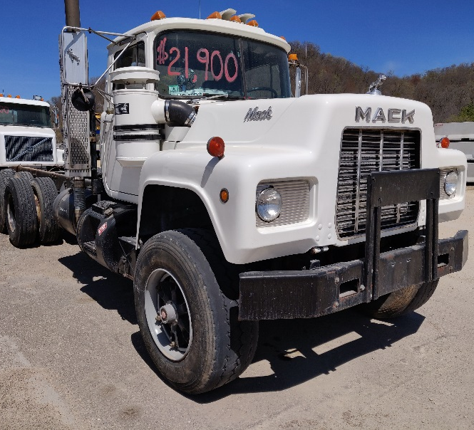 1989 Mack RD690S Dump Truck
- Price: $21,900 (Was $23,000)
- Engine: E6 250HP 4-Valve
- Transmission: Maxitorque 7-Speed – Model T2070
- Odometer: 373,190 Miles
- Front Axle Weight: 20,000 lbs.
- Rear Axle Weight: 44,000 lbs.
- Cab to Trunnion: 187”
- After Frame: 86”
- Cab Color: White
- Interior Color: Black
- Chassis Color: Black
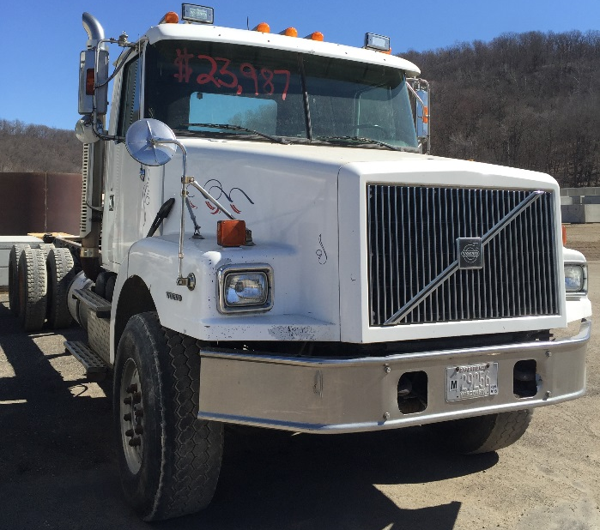 1998 Volvo WG64 Dump Truck
- Price: $20,900 (Was $23,987)
- Engine: Cummins ISM 370HP
- Transmission: Fuller RTO-1490 8LL
- Odometer: 300,174 miles
- Front Axle Weight: 18,000 lb.
- Rear Axle Weight: 20,000 lb.
- Gear Ratio: 4:30
- Rear Axles: Tandem
- Front Tires (Steers): 385/65R22.5
- Rear Tires: 11R22.5
- Cab to Trunnion: 192"
- Wheelbase: 286"
- After Frame: 86"
- Cab Color: White
- Interior Color: Black
- Chassis Color: Black

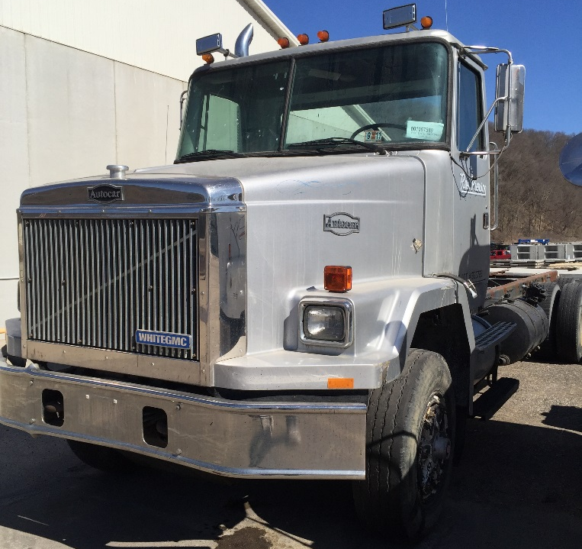 1989 Autocar Dump Truck
- Price: $13,900 (Was $14,700)
- Engine: Volvo 365 HP
- Transmission: Volvo 12 speed SR1700
- Odometer: 278,712 miles
- Front Axle Weight: 19,000 lbs.
- Rear Axle Weight: 46,000 lbs.
- Front Tires (Steers): 13/80R20
- Rear Tires: 11R22.5
- Cab to Trunnion: 192"
- After Frame: 81"
- Cab Color: Silver
- Interior Color: Grey
- Chassis Color: Black

